7th

____ 1. Cells are
a. | the structures that contain all of the materials necessary for life.
b. | found in all organisms.
c. | sometimes specialized for particular functions.
d. | All of the above

____ 2. Which of the following is a true statement about all living things?
a. | They cannot sense changes in their external environment.
b. | They have one or more cells.
c. | They do not need to use energy.
d. | They reproduce asexually.

____ 3. Organisms must have food because
a. | food is a source of energy. | c. | organisms never make their own food.
b. | food supplies cells with oxygen. | d. | All of the above

____ 4. A change in an organism's environment that affects the organism's activities is a
a. | response. | c. | metabolism.
b. | stimulus. | d. | producer.

____ 5. When a duck dives under water, its inner eyelids automatically raise to cover the duck's eyes. In this case, water acts as
a. | homeostasis. | c. | a reaction.
b. | a stimulus. | d. | an enzyme.

____ 6. Maintaining a body temperature of 37°C and a stable amount of sugar in your blood are both examples of
a. | homeostasis. | c. | photosynthesis.
b. | metabolism. | d. | respiration.

____ 7. A monkey is made up of trillions of
a. | stimuli. | c. | eggs.
b. | minerals. | d. | cells.

____ 8. Which of the following is NOT found in animal cells?
a. | cell wall | c. | lysosomes
b. | cell membrane | d. | vesicle

____ 9. Different ____ work together in an organ.
a. | organ systems | c. | organisms
b. | tissues | d. | prokaryotes

____ 10. Which of the following refers to all of the organisms in a particular area?
a. | population | c. | community
b. | ecosystem | d. | organelles

____
11. Which of the following are NOT covered by a membrane?
a. | Golgi complex | c. | ribosomes
b. | mitochondria | d. | None of the above

____ 12. Which of the following statements is NOT part of the cell theory?
a. | The most basic component of any organism is the cell.
b. | All cells originate from other cells.
c. | All cells have a nucleus and a cell membrane.
d. | All living things are made up of one or more cells.

____ 13. Which of the following is an example of a tissue in your body?
a. | blood | c. | muscle cells
b. | fat | d. | All of the above

____ 14. Which of the following is an example of an organ?
a. | a plant leaf | c. | heart
b. | stomach | d. | All of the above

____ 15. Which of the following best describes the function of the nervous system?
a. | It breaks down food into very small particles so that it can be used by all of your body's cells.
b. | It transmits information back and forth between your brain and the other parts of your body.
c. | It takes oxygen into your body and expels carbon dioxide.
d. | It keeps blood and oxygen flowing through all parts of your body.

____ 16. ____ are the basic units of living things.
a. | Organisms | c. | Cells
b. | Tissues | d. | Organs

____ 17. Why is an elephant larger than a human?
a. | It has larger cells than a person does.
b. | It has a larger surface-to-volume ratio of its cells than a person does.
c. | It has more cells than a person does.
d. | None of the above

____ 18. Genes are found on
a. | chromosomes. | c. | proteins.
b. | alleles. | d. | anthers.

____ 19. The process that produces sex cells is
a. | mitosis. | c. | meiosis.
b. | photosynthesis. | d. | probability.

____ 20. The passing of traits from parents to offspring is
a. | probability. | c. | recessive.
b. | heredity. | d. | meiosis.

____ 21. If you cross a white flower (with the genotype pp) with a purple flower (with the genotype PP), the possible genotypes of the offspring are
a. | PP and pp. | c. | all PP.
b. | all Pp. | d. | all pp.

____ 22. How many chromosomes are present in a normal human sex cell?
a. | 22 | c. | 46
b. | 23 | d. | 92

____ 23. The set of instructions for each characteristic donated by the parent to the offspring is called
a. | mitosis. | c. | heredity.
b. | genes. | d. | meiosis.

____ 24. How many sets of instructions for each characteristic does a fertilized egg receive from EACH parent?
a. | 1 | c. | 3
b. | 2 | d. | 4

____ 25. Although Darwin did not realize it, the variations he observed among the individuals of a population of finches were caused by
a. | genetic resistance. | c. | fossils.
b. | mutations. | d. | selective breeding.

____ 26. The theory of evolution combines the principles of
a. | natural selection and artificial selection.
b. | natural selection and genetic resistance.
c. | selective breeding and genetic inheritance.
d. | natural selection and genetic inheritance.

____ 27. A human's arm, a cat's front leg, a dolphin's front flipper, and a bat's wing
a. | have similar kinds of bones.
b. | are used in similar ways.
c. | share many similarities with insect wings and jellyfish tentacles.
d. | have nothing in common.

____ 28. What body part of the Galápagos finches appears to have been MOST modified by natural selection?
a. | their webbed feet | c. | the bone structure of their wings
b. | their beaks | d. | the color of their eyes

____ 29. The opposable thumb allows humans to grasp objects firmly. Because this feature helped humans to survive over time, it is called a(n)
a. | adaptation. | c. | mutation.
b. | genetic variation. | d. | vestigial structure.

____ 30. Individuals in a population that have traits or abilities that give them a competitive advantage over other population members are more likely to survive and reproduce. This principle is called
a. | species separation. | c. | genetic mutation.
b. | genetic resistance. | d. | natural selection.

____
31. The red-eyed tree frog, the smoky jungle frog, and the strawberry dart-poison frog all have their own ____, which help them to survive life in a tropical rain forest.
a. | adaptations | c. | vestigial structures
b. | speciations | d. | selective breedings

____ 32. Structures and behaviors for finding food, protection, and for moving from place to place are an organism's ____ to its environment.
a. | selective breedings | c. | adaptations
b. | speciations | d. | traits

____ 33. In order for the red-eyed tree frog to produce fertile offspring, it should mate with its own species, which is
a. | any frog. | c. | the tropical rain forest frog.
b. | the red-eyed tree frog. | d. | any amphibian.

____ 34. According to Darwin, the four steps in natural selection are
a. | reproduction, genetic mutation, separation, and natural breeding.
b. | natural breeding, genetic variation, adaptation, and reproduction.
c. | separation, genetic variation, adaptation, and natural selection.
d. | overproduction, genetic variation, struggle to survive, and successful reproduction.

____ 35. "Kings Play Chess On Fine-Grained Sand" is a mnemonic device that helps one remember
a. | the scientific names of different organisms.
b. | the six kingdoms.
c. | the seven levels of classification.
d. | the difference between prokaryotic and eukaryotic cells.

____ 36. The seven levels of classification, from general to specific, are:
a. | kingdom, class, order, phylum, family, genus, species.
b. | kingdom, phylum, class, family, order, genus, species.
c. | kingdom, phylum, class, order, family, genus, species.
d. | kingdom, class, phylum, order, family, genus, species.

____ 37. The scientific name for a skunk is Mephitis mephitis, which specifies the skunk's
a. | kingdom and class. | c. | class and species.
b. | genus and species. | d. | class and genus.

Below is a branching diagram showing the evolutionary relationships between organisms that are in the same kingdom. Examine the illustration and answer the questions that follow.

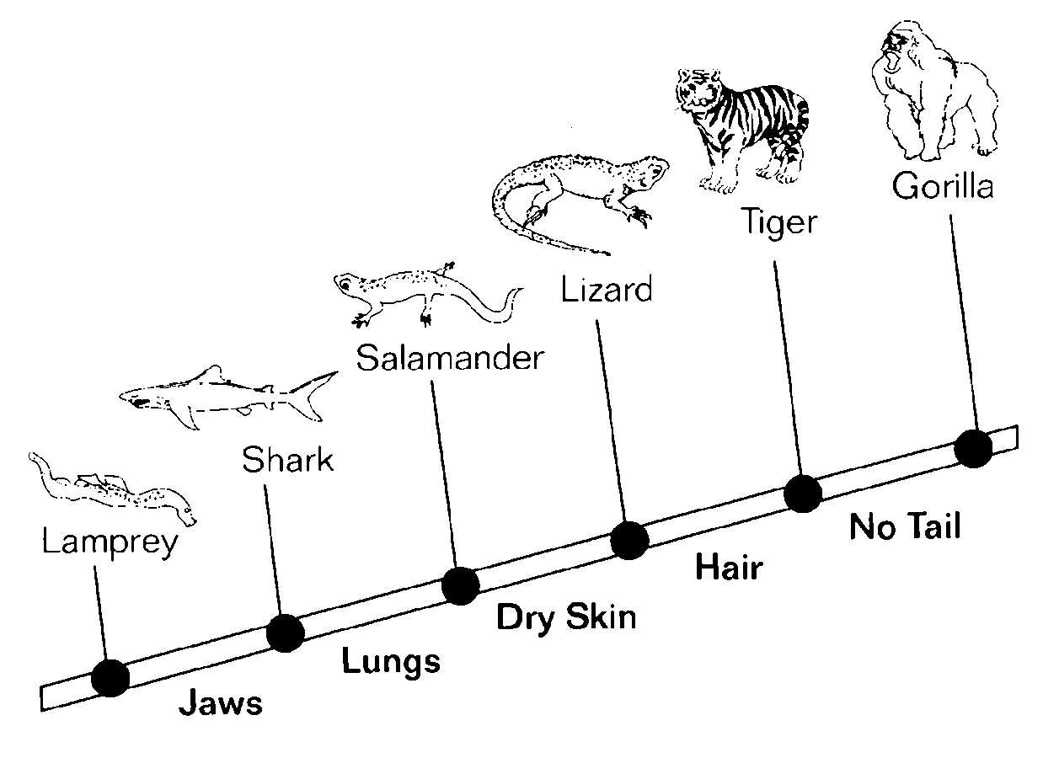

____ 38. The branching diagram above shows
a. | what makes each species unique from the other.
b. | that they came from a common ancestor.
c. | the evolutionary relationships between them.
d. | All of the above

____ 39. The words to the right of the tree most likely indicate the characteristics
a. | they have in common. | c. | that none of the animals have.
b. | that make the next animal unique. | d. | All of the above

____ 40. Resources such as water, food, or sunlight are more likely to be limiting factors
a. | when population size is decreasing.
b. | when predators eat their prey.
c. | when the population is small.
d. | when a population is approaching the carrying capacity.

____ 41. "Nature's recyclers" are
a. | predators. | c. | producers.
b. | decomposers. | d. | omnivores.

____ 42. How energy moves through an ecosystem can be represented by
a. | food chains. | c. | food webs.
b. | energy pyramids. | d. | All of the above

____ 43. The base of an energy pyramid represents which organisms in an ecosystem?
a. | producers | c. | herbivores
b. | carnivores | d. | scavengers

____
44. Which of the following is the correct order in a food chain?
a. | sun → producers → herbivores → scavengers → carnivores
b. | sun → consumers → predators → parasites → hosts
c. | sun → producers → decomposers → consumers → omnivores
d. | sun → producers → herbivores → carnivores → scavengers

____ 45. The plants a ladybug lives on, the aphids that the ladybug eats, and the birds that would eat the ladybug are all
a. | biotic parts of the environment.
b. | physical factors in the environment.
c. | abiotic parts of the environment.
d. | involved in predatory-prey relationships.

____ 46. The ____ part of the environment includes all of the physical factors—such as water, soil, light, and temperature—that affect organisms living in a particular area.
a. | ecological | c. | abiotic
b. | biospherical | d. | biotic

____ 47. Which of the following is an abiotic part of a desert?
a. | cacti | c. | temperature
b. | sand | d. | both (b) and (c)

____ 48. Which of the following is a biotic part of a desert?
a. | cacti | c. | temperature
b. | sand | d. | both (b) and (c)

____ 49. Which of the following is an example of a population?
a. | a flock of birds flying south for the winter
b. | all of the bullfrogs in a pond
c. | a herd of sheep grazing in a field
d. | all of the above

____ 50. The old adage, "birds of a feather flock together" describes which level of environmental organization?
a. | a population | c. | the biosphere
b. | an organism | d. | an ecosystem

____ 51. ____ is the source of energy for almost all living things.
a. | Sunlight | c. | Soil
b. | Water | d. | Food

____ 52. A(n) ____ is a consumer that eats both plants and animals.
a. | decomposer | c. | carnivore
b. | omnivore | d. | herbivore

____ 53. Suppose that the organisms in each level of an energy pyramid use 90 percent of the energy from the previous level. If an insect eats a plant and a bird eats the insect, about how much energy from the plant is stored in the insect for the bird to use?
a. | 90 percent | c. | 10 percent
b. | 81 percent | d. | 1 percent

____ 54. Which of the following processes produces carbon dioxide?
a. | decomposition | c. | combustion
b. | respiration | d. | all of the above

____ 55. Which of the following statements about cycles of matter is true?
a. | Matter is lost in each cycle.
b. | Human activity has little or no impact on cycles.
c. | Each cycle involves evaporation and condensation.
d. | Matter is moved between the physical environment and living organisms.

____ 56. Carbon from the nonliving environment becomes a part of living organisms through
a. | photosynthesis. | c. | transpiration.
b. | respiration. | d. | absorption.

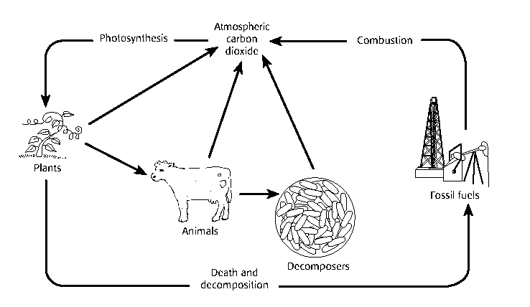

____ 57. How do the living organisms in the diagram return carbon to the atmosphere?
a. | by way of precipitation
b. | through the process of photosynthesis
c. | by breaking down sugar molecules during respiration
d. | by breaking down inorganic molecules during transpiration

____ 58. What is the source of carbon in fossil fuels?
a. | combustion and respiration
b. | carbon captured during nitrogen fixation
c. | the buried remains of long-dead organisms
d. | carbon dioxide in ground water

