The savory swimmer swims north?
February 15, 2015 David S Johnson
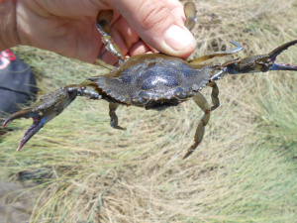
In the summer of 2012 I was having dinner with colleagues when one offhandedly said that he’d seen a blue crab, Calinectes sapidus in the marsh (the Great Marsh in northeast Mass.). I was incredulous! He was claiming that a blue crab was in the Great Marsh, far north of its northern limit of Cape Cod.
Then other sightings of blue crabs in the Great Marsh were reported.
A blue crab (Callinectes sapidus) found north of Cape Cod in 2012. Plum Island Estuary, Massachusetts

I grabbed a long-handled net and walked the tidal creek bottoms. I saw many green crabs scuttle but then, in a deep pool, I saw a crab swim sideways and instantly knew it was a blue crab (blue crabs are in the family Portunidae which are swimming crabs with flattened back legs). I found three more that summer.
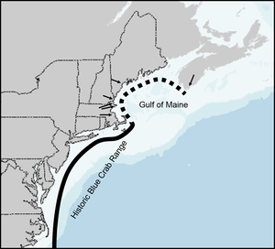
Finding a blue crab in the Great Marsh was surprising because the marsh lies in the Gulf of Maine which extends from Cape Cod to Canada and is kept cold by cold water currents from Canada. Water too cold for blue crabs.
Using the list-serves, Twitter and colleagues I crowd-sourced information about observations of blue crabs throughout the Gulf of Maine and from 2012 – 2014 these often-called ‘Maryland’ crabs were found as far north as Maine and Nova Scotia. The reason? I hypothesize warming oceans. Water temperatures in 2012 and 2013 were much warmer than the average of the previous decade which may have lowered the temperature barrier. Earlier I reported on a similar range extension for the fiddler crab.
Solid line: historic blue crab distribution. Dashed line: potential new range extension. Arrows indicate sightings of crabs from 2012-2014.
It may be a logical fallacy to talk about climate change and warming seas when Boston is undergoing record snows (record-breaking snows are consistent with climate-change theory as warmer air holds more moisture prior to storm events), but we cannot deny that the climate is changing. One prediction of climate change is that as the climate and oceans warm species will start shifting where they are found. We’ve seen this already in many commercial species such as hake, flounder, and lobsters in the northeast where the concentration of their biomass has shifted north. The Connecticut lobster fishery (CT the southern end of the lobster’s distribution) is severely depleted, possibly in part to lobsters moving north.
What makes my observations of blue crabs north of Cape Cod unique is that this is the first time a commercially important species has been reported to potentially expand into the Gulf of Maine. It should be noted that in the past 150 years there have been four other reports of blue crabs in the Gulf of Maine, but none of those populations were permanent. It’s still to be seen if the 2012 blue crab population is a permanent extension of their range. If so, then it means that crab cakes are expanding north thanks to climate change.

