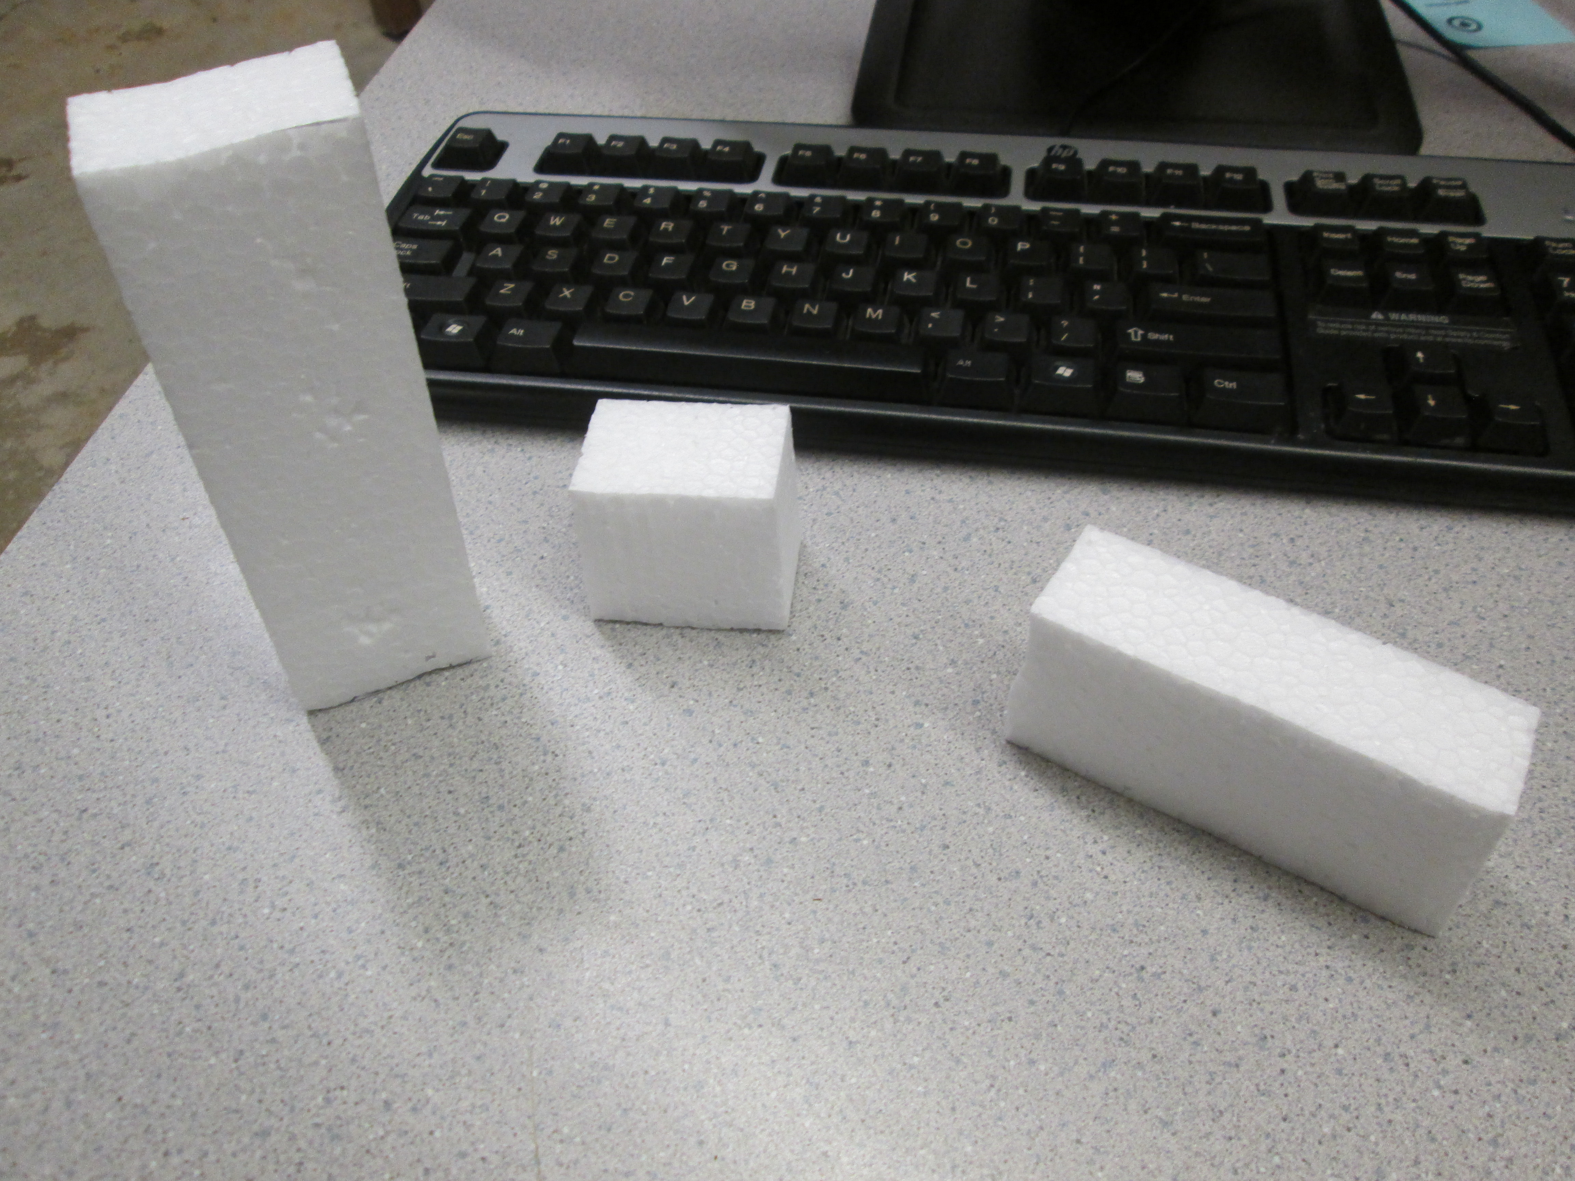

- Predict the amount of matter in each block from greatest to least.

- Predict the mass of each block from greatest to least.

- Predict the weight from greatest to least. Explain the connection between mass and weight.

- Predict the density of each cube and compare them to each other.

