**Activity 1: Continental Drift and Plate Tectonics Webquest:**

**Name ____________________________________**

*Use complete and thorough answers through this assignment—use a different color font. Feel free to use images to help explain!*

**Structure of Earth**

*Visit the following site.* [*Savage Earth Animation: The Hot Zones*](http://www.pbs.org/wnet/savageearth/animations/hellscrust/index.html)

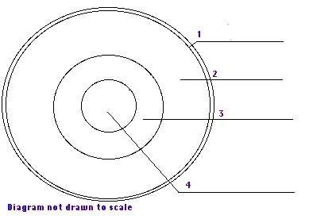

*Name the four layers of Earth as numbered in the diagram above. Indicate the average thickness and whether it is solid or liquid.*

|  |  |  |  |
| --- | --- | --- | --- |
| Diagram number | Layer | Average Thickness | Solid or Liquid |
| 1 |  |  |  |
| 2 |  |  |  |
| 3 |  |  |  |
| 4 |  |  |  |

*Use any website to define (provide link)*



Lithosphere

Asthenosphere

Biosphere

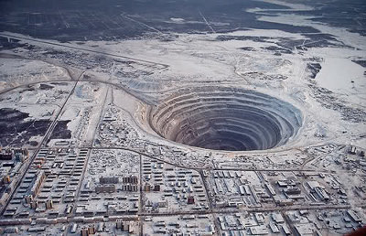*Read the article from the link below and answer the following questions.*

[*Savage Earth: Probing the Depths*](http://www.pbs.org/wnet/savageearth/hellscrust/html/sidebar1.html)

What is the Kola well and explain why it does is not helpful in understanding much about rock formation beneath the crust.

The article describes four others ways in which scientists could reasonably study the mantle. Describe each of those and state why they are more reasonable than the Kola well.

The article refers to “natural conduits” or “kimberlite pipes”. What are they and how are they important today? (see: [Diamond Geology & Kimberlite Pipes](http://www.allaboutgemstones.com/diamond_geology.html))

There are different waves generated during earthquakes. Two of the waves are s and p waves. What is the relationship between velocity of those waves and the temperature through which they travel? Which waves are transverse and which are longitutinal?

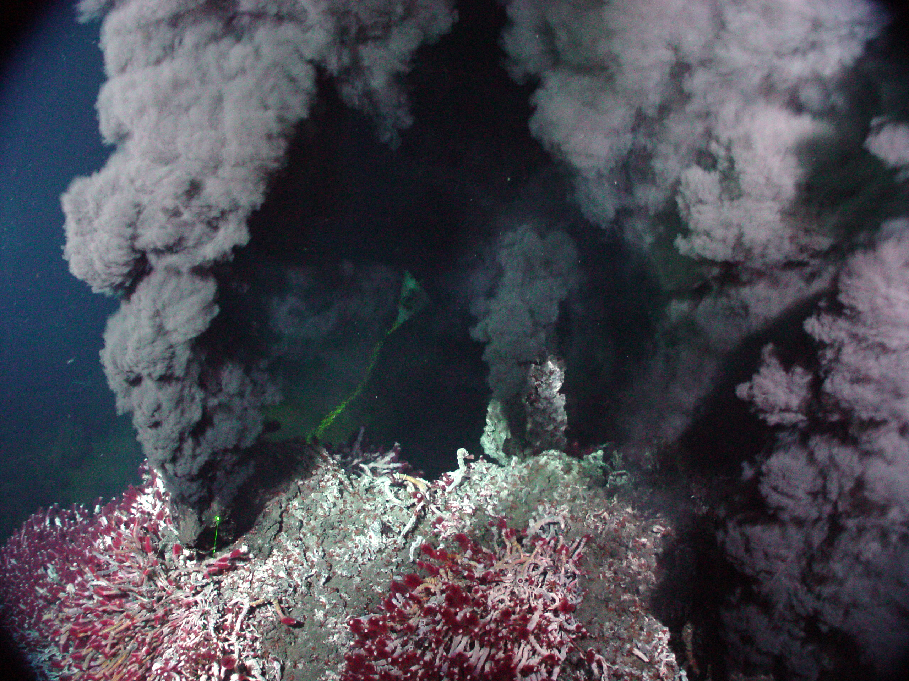*Read the article from the link below and answer the following questions.*

[*Savage Earth: Black Smokers*](http://www.pbs.org/wnet/savageearth/hellscrust/html/sidebar2.html)

Where are hydrothermal vents found?

What is a black smoker?

Why is it so unusual that life is found near these vents?

**Continental Drift**

*Use this site to answer the following questions:* [*CONTINENTAL DRIFT - Paleontology and Geology Glossary*](http://www.enchantedlearning.com/subjects/dinosaurs/glossary/Contdrift.shtml)

What does the Theory of Continental Drift state?

What is the name of the scientist that proposed the Theory of Continental Drift?

What was Pangaea?

What are the names of the two continents that Pangaea separated into?

*Use this hyperlink next:* [*The Pangaea Theory*](http://library.thinkquest.org/17701/high/pangaea/)

It has been proven that the Earth's present continents were once together as a Pangaea as seen from:

1. __________________________________________________________

2. __________________________________________________________

3. __________________________________________________________

4.__________________________________________________________

*Click the “Piece” icon at the bottom of the page to advance one at a time, through the next few screens to answer these questions.*

How do the continental coastlines support the Theory of Continental Drift (Pangaea Theory)?

Explain how fossil distribution supports the Theory of Continental drift.

How do distinctive rock strata support the Theory of Continental Drift?

How does coal distribution support the Theory of Continental Drift?

**Convection Current**

*Use the following site:* [*Convection Currents*](http://volcano.oregonstate.edu/education/vwlessons/lessons/Earths_layers/Earths_layers7.html)

What are convection currents?

In which of Earth’s layers do convection currents happen?

When convection currents flow in the mantle, they also move the ____________ .

*Find and image from a different site that could be used to teach younger children about convection currents in Earth.*

**Plate Tectonics**

Use this website: [This Dynamic Earth--Contents [USGS]](http://pubs.usgs.gov/gip/dynamic/dynamic.html)

***Click on the “Historical Perspective” icon on this website.***

What is a “plate” in geological terms?

What does the Theory of Plate Tectonics state?

What is the name of the theory that led to the development of the Theory of Plate Tectonics?

*Click the back arrow of Internet Explorer to return to the homepage. Click on the “Understanding Plate Motions” icon on this website.*

|  |  |  |
| --- | --- | --- |
| Plate boundary | Type of interaction | Image (from different source) |
|  |  |  |
|  |  |  |
|  |  |  |
|  |  |  |

**Plate Tectonics: Types of Boundaries: Divergent boundaries**

*Click the back arrow once on the Internet Explorer screen to move back one page. Scroll down to: Divergent Boundaries.*

## 

## *Finish the following sentence.*

Divergent boundaries occur along spreading centers where ___________________ are moving __________________ and new crust is created by _________________ pushing up from the _________________.

C*lick on the link:* [Mid-Atlantic Ridge](http://pubs.usgs.gov/gip/dynamic/ridge.html) [26 k]

What is shown in this picture? What type of plate boundary is it? Where is it located?

**Plate Tectonics: Types of Boundaries: Convergent Boundaries**

*Scroll down to: Convergent Boundaries.*

What is the location where sinking of a plate occurs is called? _______________________ _____________________.

The type of convergence -- called by some a very slow "collision" -- that takes place between plates depends on the kind of lithosphere involved. Convergence can occur between what types of plates?

### *Scroll down to: Oceanic-continental convergence*

Off the coast of South America along the Peru-Chile trench, the oceanic Nazca Plate is pushing into and being subducted under the continental part of the South American Plate creating what?

*Look at the diagram under the Oceanic-continental convergence information: Label diagram.*

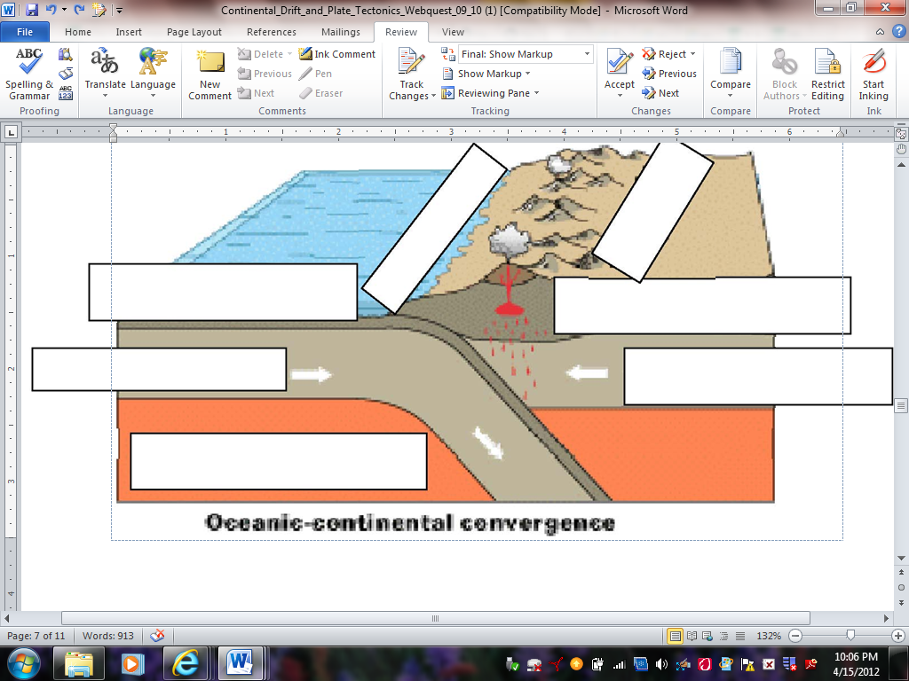



1.



2.

3.

4.

5.

6.

7.

*Click on the* [*Ring of Fire*](http://pubs.usgs.gov/gip/dynamic/fire.html) *[76 k]*

What is the ring of fire?

The Ring of fire results in frequent what?

The West coast of the United States has frequent volcanoes, use the ring of fire to explain why.

#### *Scroll down to: Oceanic-Oceanic convergence*

When two oceanic plates converge, one is usually subducted under the other what is formed?

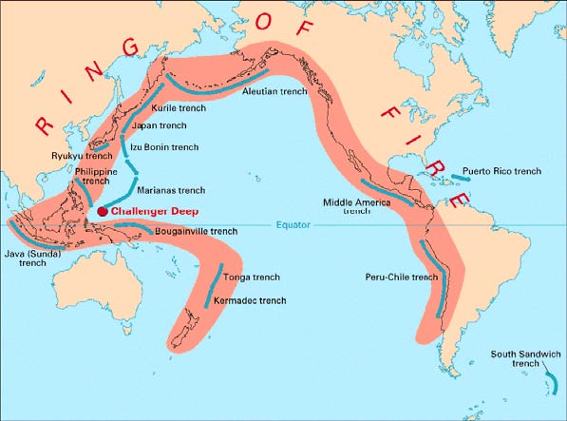

*Scroll down to: Continental-continental convergence*

What mountain range demonstrates one of the most visible and spectacular consequences of plate tectonics?

What happens when two continents meet head-on, meet head-on and neither is subducted?

*Look at the diagram under the Continental-continental information:*

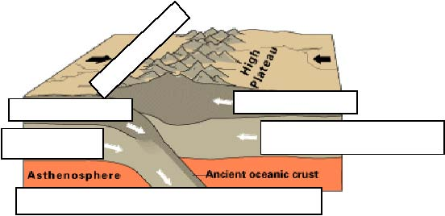



1.

2.

3.

4.

5.

6.

**Plate Tectonics: Types of Boundaries: Transform Boundaries**

*Scroll down to: Transform Boundararies:*

The zone between two plates sliding horizontally past one another is called a *transform-fault boundary,* or simply a *________________________ _____________________________.*

*Click on the diagram* [*San Andreas fault*](http://pubs.usgs.gov/gip/dynamic/San_Andreas.html) *[52 k]*

[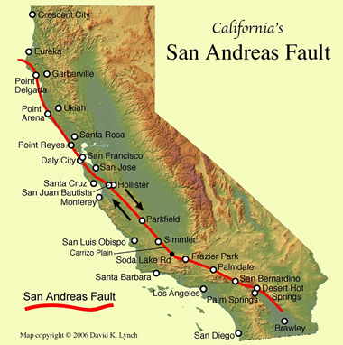](http://geology.com/articles/images/san-andreas-fault-map.jpg)

The picture is an aerial view of what?

Make three observations about the picture

What type of boundary does it results from?