Sample Engineer’s Notebook Entries

Keeping notes during class is a task that you have come to expect. You also have learned in mathematics class, for example, that a record of your work helps you to explain to your teacher what you were thinking when you solved a mathematics problem. The same is true with engineers. They must keep record of the steps they take while developing a solution, the processes they use in creating the solution, and a record of their solutions. The engineer’s notebook is so important that it can be considered a legal document. As a legal document, the Engineering Notebook is commonly used in the pursuit of a patent. This activity is designed to help you set up your notebook and to learn how to keep record of the work you will do in this class. In addition, your teacher may ask you to take notes from information presented or learned in class. Carefully read the information below.

Engineering Notebook Procedures
Each engineer has his or her own engineer’s notebook. The engineer records all work related to project development by hand as neatly and organized as possible. Entries must be kept in chronological order.
Below are examples of the types of information that you will record in your engineer’s notebook:
- Your thoughts and ideas (should be stated or presented in a way that can be clearly understood)
- Sketches and pictures documenting the design process - (preferably with annotated sketches)
- Work session activities - (new, supported, or theorized concepts)
- Research findings (testing, observations, and results) – (reference information for all sources)
- Interview information (who was contacted, why, when, and what was discussed or learned)
Each day you may be required to create a journal entry. Each journal entry may include the following:
Briefly explain what you accomplished during the class period. This should include statements such as: I researched . . . I wrote . . . I drew . . . I built . . . I tested . . . I found . . .
- Important dates for concepts, calculations, test results, improvements, and project completion.
- Briefly explain the importance of any performed activities.
- Your teacher may ask you to include additional information in your notebook such as:
taking class notes, defining vocabulary words, or answering questions at the end of a lesson.

PLTW Engineering Notebook Standards
(The following standards should be applied at ALL times)
- Pages are, or can be, sequentially numbered in permanent ink at the top corner of each page.
- The Notebook must be bound. Pages cannot be added or removed without disrupting the binding.
- No data recording pages are to be removed from the notebook for any reason.
- Your notebook should be stored in a safe location when not in use. (not accessible to others)
- When the notebook is full, begin a new one that picks up where the other ended. (archive old notebook)
- All figures and calculations should be clearly labeled and printed in permanent ink.
- Entries start at the top of the page, working left-to-right and top-to-bottom. Do not leave open or
- Unused space. Simply draw lines through blank or unused space as entries are made.
- Markers that can bleed through the paper are not to be used. (Permanent ink entries are preferred)
- Permanently attach inserted items with tape or a glue stick. Loose items do not belong in the notebook.
- Clearly indicate the date before or above each new entry.
- Cross out mistakes with a single line. Initial and place the correction nearby. NEVER erase an entry.
- Always be consistent, accurate, and chronological when recording entries in your notebook.
- Sign and date each completed entry page before you begin the next page. When dating a completed entry page, use the following universal format: Month Day, Year - Example = May 15, 2009
- An engineer’s notebook is considered to be Proprietary Information. This means it is privately owned.
- A colleague or your teacher should look over the entries on each page and sign/date as the witness in the designated boxes. Excluding the witness, no one other than yourself should write in your notebook.
Reminders for a Successful Engineering Notebook
Be Prepared: Bring your notebook and pen/pencil every day. Good attendance will aid in your success.
Ask Questions: Ask questions to clarify any confusion. Being a good listener will also help greatly.
Be Organized: Use a systematic approach – be brief, neat, structured, sequential, and consistent.
Examples: Review (Ideal Journal Entries) to eliminate mistakes and improve consistency.
Resources: Utilize all available resources. This notebook contains resource information for:

The following would be considered excellent examples of entries in an engineer’s notebook.

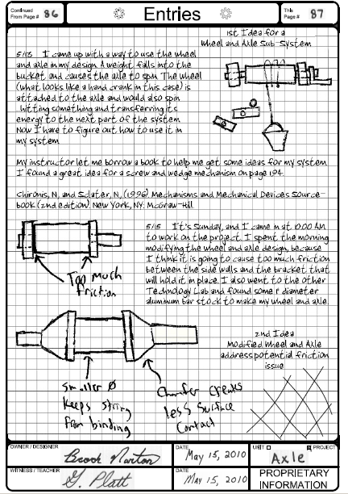

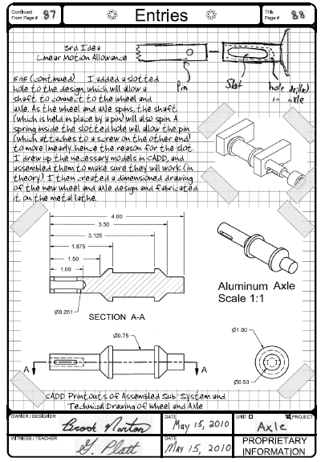

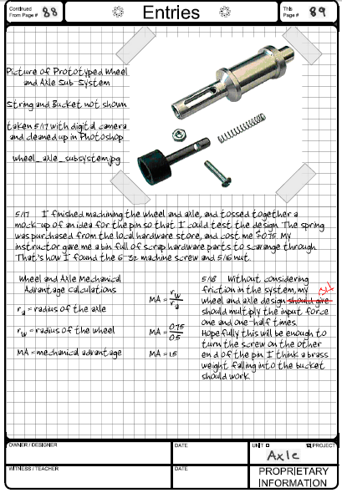

Why did the previous examples represent an excellent engineer’s notebook?
- The pages have been sequentially numbered.
- The pages are part of a bound notebook.
- There is a dedicated location on each page for the designer’s and witness’s dated signatures.
- All figures and calculations have been clearly labeled.
- Inserted items have been properly attached to their respective pages.
- The date for each entry is clearly identified.
- The student included annotated sketches that help the reader understand the ideas.
- Detailed explanations of how the designs are supposed to work were given.
- The student gave evidence of research.
- Problems that were encountered through experimentation were chronicled, and ideas to fix problems were clearly evident.
- A technical drawing for a prototype was given, which specified the material from which the part was to be made.
- A digital photograph of the prototype was included that suggests how the object is to be assembled.
- The information given in the entries is proportional to the amount of time given per class period.
- Any mistakes had a single line drawn through them and were initialed.
The following is an example of an unacceptable engineer’s notebook. Keep in mind that each entry represents a reflection of 45 minutes of continuous work.

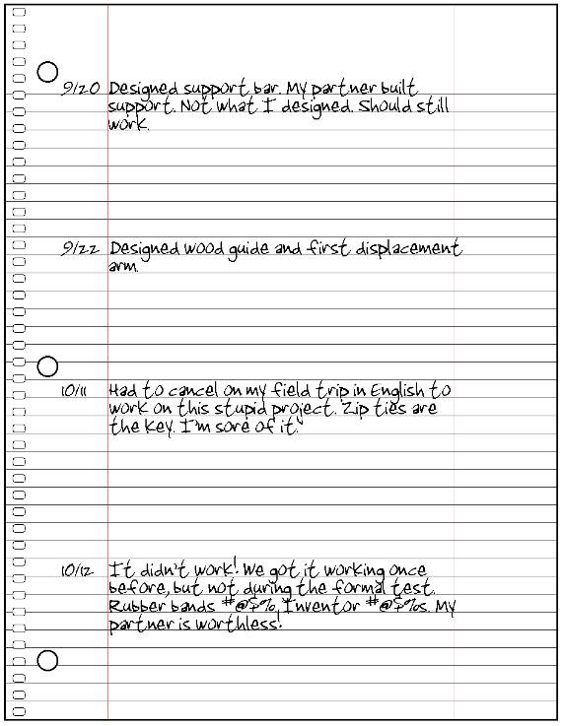

Why did the previous example represent an unacceptable engineer’s notebook?
- The student submitted a sheet of loose leaf paper that was removed from a wire bound spiral notebook. An engineer’s notebook must be a bound document. No pages should ever be removed from an engineer’s notebook.
- The page number is not identified in ink.
- The student did not sign and date the page.
- There were several class days between 9/22 and 10/11 that are not represented by notebook entries.
- There were no sketches, CAD model graphics, or technical drawings to support the idea that the support bar, guide, or displacement arm was actually designed or being built. It also appeared that the student was leaving room so that he/she could go back and add sketches later on in an attempt to satisfy the rubric.
- Except for wood, which encompasses a broad spectrum, no tools or materials were identified as being used.
- The student offered no explanation as to functions of the support bar, wood guide, and displacement arm.
- The entries do not show that the partners talked about their ideas or worked on their designs as a team.
- The entries do not talk about any special considerations or problems that might have been encountered during the design of the parts.
- Only fragments of ideas have been documented. There is no detail at all.
- The student used inappropriate expletives in a formal document, and was openly disrespectful to his/her teammate.
- 45 minutes of work cannot be accurately and completely summed up in one sentence.

